**A high density linkage map of New Zealand mānuka (*Leptospermum scoparium* L.) constructed using genotyping by sequencing and quantitative trait loci for tree growth**

David Chagné1,4*, Julie Ryan1, Munazza Saeed1, Tracey Van Stijn2, Rudiger Brauning2, Jeanne Jacobs3, Philip Wilcox4, Emma Boursault1, Peter Jaksons6, Dan Jones5, Amali Thrimawithana5, Kathy Schwinn1, David Lewis1

1 The New Zealand Institute for Plant & Food Research Limited (Plant & Food Research), Palmerston North Research Centre, Palmerston North, New Zealand

2 AgResearch, Invermay, New Zealand

3 AgResearch, Lincoln, New Zealand

4 University of Otago, Dunedin, New Zealand

5 Plant & Food Research, Mount Albert Research Centre, Auckland, New Zealand

6 Plant & Food Research, Lincoln, New Zealand

* Corresponding author

**Abstract**

**Keywords:** SNP; Myrtaceae; Eucalyptus; genome;

**Introduction**

Mānuka (*Leptospermum scoparium* J.R.Forst. et G.Forst. var. *scoparium*; Myrtaceae) is a tree shrub indigenous to New Zealand belonging to the Myrtaceae family. In New Zealand, it displays a wide range of morphological and chemical diversity across its natural distribution, which is throughout both the North and South Islands from coastal situations to low alpine habitats. Scientific knowledge on mānuka is being built up due to growing honey and essential oil industries, and recently molecular tools were developed such as a set of simple sequence repeat markers useful for DNA fingerprinting (Chagné et al. 2017) and a whole genome assembly (Thrimawithana et al. 2018).

Linkage maps are useful tools both for understanding the genetic control of traits and for anchoring genome assembly scaffolds into pseudo-chromosomes. Although linkage maps are available for members of the Myrtaceae family, most of these are for the *Eucalyptus* genus (Byrne et al. 1995; Agrama et al. 2002; Brondani et al. 2006; Freeman et al. 2006; Sansaloni et al. 2010; Neves et al. 2011; Hudson et al. 2012a; Kullan et al. 2012b), which has become the central genus for the family (Grattapaglia et al. 2012). The *Eucalyptus* linkage maps have been used to identify genomic regions linked to quantitative traits such as wood quality (Grattapaglia et al. 1996; Thamarus et al. 2004; Freeman et al. 2009; Thumma et al. 2010; Gion et al. 2011; Kullan et al. 2012a; Freeman et al. 2013), foliage chemical composition (Henery et al. 2007; Freeman et al. 2008a; Kulheim et al. 2011) and disease resistance (Freeman et al. 2008b; Butler et al. 2016; Rosado et al. 2016). Alignment of linkage maps by comparative genome mapping using markers in common indicated a high degree of genome synteny between *Eucalyptus grandis, E. urophylla* and *E. globulus* (Hudson et al. 2012b). Only two linkage maps have been developed for Myrtaceae species outside of the *Eucalyptus* genus; *Corymbia* (Shepherd et al. 2006; Lepitre et al. 2010), which until recently was classified as *Eucalyptus*, and *Psidium* (Shepherd et al. 2006; Lepitre et al. 2010). As the family contains approximately 6,000 species across 132 genera, genetic data for more genera is desirable.

Many methods can be employed for generating the genetic markers necessary for linkage map construction. Microsatellite (or simple sequence repeats) markers were developed for mānuka (Chagné et al. 2017), however, in insufficient numbers for constructing a fully saturated linkage map. Genotyping by sequencing [GBS; (Elshire et al. 2011)] is an attractive method for linkage map construction as it can generate thousands of markers rapidly. The principle of GBS is that re-sequencing is performed on a fraction of the genome for many individuals in parallel, making use of high-throughput short read sequencing. Reduced representation of the genome is achieved using restriction enzyme digestion, followed by ligation of adapters containing both DNA barcodes enabling the deconvolution of many individuals and universal sequencing oligonucleotides. Bioinformatics analysis of the sequencing data then enables variant calling such as for single nucleotide polymorphisms (SNPs). GBS has been used for making linkage maps of many tree species (Ipek et al. 2016; Norelli et al. 2017; Marinoni et al. 2018).

The objective of this study was to construct a high density linkage map for New Zealand mānuka using GBS and a segregating population developed from accessions from the East Cape region of New Zealand.

**Material and methods**

*Segregating population, genotyping by sequencing and linkage mapping*

A segregating population (EC201xEC103) was developed by crossing two accessions (EC201 and EC103) that were collected in the East Cape region of New Zealand in 2003. Consent was given by the Māori iwi Ngati Porou for collecting the original samples and for using this material for the purpose of constructing a genetic linkage map. A total of 185 seedlings were obtained from a cross made in January 2015. Seeds were germinated in April 2015, potted into 5cm pots in May 2015 and then 15cm bags in July 2015. Plant were grown in a bark/pumice (1:1) potting mix with incorporated fertiliser under ambient day length in a greenhouse, vented at 21°C and heated at 16°C. Plants were transplantated into the field at Plant & Food Research, Palmerston North, New Zealand in May 2017. Plants were transplanted over a two day period and pruned at time of transplanting on the first day but not the second. Leaf samples were collected in May 2016 from the greenhouse grown plants and DNA was extracted using a modified CTAB protocol. One microgram of high molecular weight genomic DNA was sent for GBS library preparation at AgResearch Ltd.

*Genotyping by sequencing library construction, sequencing and SNP calling*

Restriction, library prep protocol. Sequencing conditions. SNP calling.

*Linkage map construction*

Genetic map construction was carried out using JoinMap 3® ([www.kyazma.nl](http://www.kyazma.nl)) using SNP markers segregating as backcross type for each parent, following the double pseudo-testcross strategy (Grattapaglia and Sederoff 1994). The genetic distance within the group was calculated using the Kosambi function. The following parameters were used for the map construction: no third round of mapping was performed and the goodness-of-fit threshold for removal of loci was set to 2.

*Tree height phenotyping, mixed model adjustment and QTL mapping*

The EC201xEC103 segregating population was phenotyped for tree height on April 20th 2018. The height of the primary axis was measured from the ground to the tree apex.

Tree height was normally distributed in the progeny, however a block effect was observed in the field due to the population being planted in two batches and receiving different pruning. To take into account this pruning effect on tree height and any other field trial row by tree spatial effects, a linear mixed effects model was fitted to obtain adjusted relative tree heights. The fitted model included, pruning batch, row and tree as random effects and a 2 dimensional spline term was incorporated into the model to account for the global spatial trend. In order to get more accurate predictions for this none replicated trial the genomic relationship variance-covariance matrix was fitted as a covariance structure. The model was fitted in R3.3.4 (R Core Team, 2017) using the ‘sommer’ package (Covarrubias, 2016).

Quantitative trait loci (QTL) analysis was performed with MapQTL® version 5.0 ([www.kyazma.nl](http://www.kyazma.nl)) using interval mapping (IM) analysis. The LOD threshold for significance of a QTL was calculated at the genome level using 1,000 permutations. Only the QTLs with a LOD score significant at greater than 90% genome-wide were retained. The most significant marker for each QTL was then used as a cofactor for a multiple QTL analysis (MQM) for detecting minor QTLs that were hidden by the major QTL in the previous IM analysis.

**Results**

*SNP detection*

A total of 123,769 SNPs were detected using GBS in the EC201xEC103 segregating populations over 40 super-scaffolds of the reference mānuka genome of ‘Crimson Glory’ scaffolded using Hi-C. The SNP call rate representing the proportion of genotypic data points that were not missing for each SNP across all individual samples was skewed toward high values (Figure 1a), with a median of 72.7% and 42,958 SNPs with a call rate higher than 90%. The individual sample call rate representing the proportion of SNP genotypic data points that were not missing for each individual across all SNPs was skewed towards high values (Figure 1b), with a median of 68.3%. The negative control included in the GBS libraries had a low call rate (1.2%), as well as one individual sample from the EC EC201xEC103 for which the GBS library failed (1.1% call rate). The alternate allele frequency representing the frequency of the opposite allele to the reference genome of ‘Crimson Glory’ had a distribution with peaks around 0, 0.25 and 0.5 (Figure 1c), as typical of monomorphic markers or markers segregating in a *ab* x *aa* and *ab* x *ab* fashion in the progeny, respectively. Of the 69,500 SNPs that did not have missing data for both replicates of ‘Crimson Glory’, a small set of 7,432 SNPs (1.1%) were different from the expected reference allele of the ‘Crimson Glory’ genome assembly. Of these, 5,728 (0.8%) and 1,704 (0.3%) were heterozygous and homozygous for the alternate non-‘Crimson Glory’ allele, respectively. Two replicates of each parent of the segregating population and ‘Crimson Glory’ were included in the GBS experiment enabling to assess the reproducibility of genotype calling. Of the 50,330 SNPs that did not have missing data in either of the replicates for these three individuals, 43,835 (87.1%), 44,943 (89.3%) and 47,381 (94.1%) had consistent genotype calls between the replicates of EC103, EC201 and ‘Crimson Glory’, respectively. Of the total number of SNPs with consistent genotype calls between replicates of the EC103 and EC201 parents, 20,785 were polymorphic, of which 4,562 markers were segregating in an intercross manner (both parents heterozygous for the same alleles, *ab* x *ab*) and the rest were segregating as backcross-type markers for either parent (8,470 and 7,753 for EC103 and EC201, respectively).

The genomic relationship of the 180 segregating individuals from the EC201xEC103 progeny was calculated using the set of 20,785 polymorphic markers. The distribution of genetic similarities was centred around 0.5 as expected from a full sib family, except for one individual for which the GBS library failed and mostly had missing data points.

*Linkage map construction*

Parental maps were constructed using SNP markers segregating in a backcross manner (*ab* x *aa*). Using a LOD score of 15, 4,940 and 7,389 markers grouped into 11 linkage groups (LG) for EC103 and EC201, respectively. Linkage maps were calculated and span a total of 1,242.8 and 1,616.2 cM (Figure 2). The number of mapped markers for each parent was 1,140 and 1,509, corresponding to an average of one marker every 1.1 cM for both parents. The remaining unmapped markers were due to being unlinked to any group (5,579 and 1,019 markers) or creating tensions in the LGs during the genetic distance and marker ordering process using the Joinmap software. The linkage maps aligned well with the whole genome chromosome-level assembly of ‘Crimson Glory’ (Thrimawithana et al 2018) and the LGs were numbered according to the *Eucalyptus grandis* chromosomes.

*Tree height phenotyping*

In total 172 three year old trees from the EC201xEC103 population were phenotyped for tree height. The adjusted relative tree height values calculated using the fitted mixed model were independent of the location of the tree in the block, when they were propagated and how they were pruned (Figure 3).

*QTL mapping for tree height*

In total, 10 QTLs were detected for tree height adjusted for the block effect in the field (Table 1). The threshold LOD score values obtained using 1,000 permutations were 2.8, 3.2 and 4.1 for 90%, 95% and 99% genome-wide significance, respectively. No significant QTL was detected for the raw tree height measurements. The significant QTLs were inherited from both parents (five each) and were located on LG2, 3, 6, 7, 9 and 10. The variance explained calculated using residual maximum likelihood ranged from 21.2% to 1.2%, globally explaining 72.2% of the variance, with the largest effect QTL derived from EC201 on LG3 (LOD > 12).

**Discussion**

We present the first high density linkage map for a New Zealand native tree species, constructed using thousands of genetic markers obtained by GBS.

Out of the 123,769 SNPs originally detected using GBS, a subset of 20,785 were further used for linkage map construction. The robustness of the SNP markers detected using GBS was evaluated using replicates of both parents, the reference accession used for genome sequencing and a negative control. The proportion of SNPs with consistent SNP calling between replicate was 87.1% to 94.1%, which indicates the data set is robust and the SNP calling is repeatable. The negative control had a low call rate of 1.2% as expected and only one individual samples totally failed.

The linkage map developed for both parents of the EC201xEC103 segregating population were saturated as they had 11 linkage groups as it is expected from the base chromosome number for Myrtaceae. Many markers were mapped for all 40 super-scaffolds assembled using the Hi-C technique, which indicates that these assembled sequences can be further scaffolded and the linkage map developed here is useful for assembling the mānuka genome into pseudo-chromosome level.

QTLs for tree height of young mānuka trees were detected on six linkage groups. This is the first example of QTL detected for a native New Zealand species. The QTL regions are aligned to the reference genome assembly of ‘Crimson Glory’, which will enable us to search for candidate genes underneath the QTL intervals. The detected QTL for tree height demonstrate that this trait is polygenic in mānuka and that the linkage map for EC201xEC103 is useful for QTL mapping.

**Conclusion**

The linkage map from the EC201xEC103 segregating population will be useful for identifying genomic regions linked to a range of traits such as nectar and foliage chemical composition, flowering time, tree architecture and tolerance to fungal pathogen *Puccinia psidii*. The mapping of such genomic regions will not only shed light on the genetic control traits unique mānuka but also provide genetic markers useful for marker-assisted selection.

**Acknowledgments**

Victor Goldsmith from Ngati Porou Miere Ltd and representing the Ngati Porou tribal group (iwi) approved the use of plant material from the EC201xEC103 segregating population that was developed from crossing parental trees collected within their ancestral boundaries. This research was funded by an internal “Discovery Science” project [Ministry for Business Innovation and Enterprise (MBIE), Science Strategic Investment Funding (SSIF)] and by the MBIE Endeavour project “genotyping for production and security in a biological economy”.

**Conflict of interests**

The authors declare that they have no conflict of interests. Permission from stakeholders representing the indigenous Maori tribe was obtained for using the plant material used for this study. Further studies using this material will require consent from the Maori tribe.

**Data archiving statement**

The raw data consisting of the genetic markers genotype is available on request and after consultation with the Maori iwi where the samples have been originated.

**Table 1: QTL detection for tree height in the manuka E** EC201xEC103 **segregating population.** % var REML: percentage of the phenotypic variance explained as calculated using residual maximum likelihood. GW: genome wide significance of the QTL.

**Figure 1: Performance of the genotyping by sequencing single nucleotide polymorphisms (SNPs) detected in the** EC201xEC103 **segregating population and parents.** A. SNP call rate calculated as the proportion of individuals with successful data point for each SNP. B. Individual sample call rate calculated as the proportion of SNPs with successful data point for each individual sample. C. Alternative allele frequency.

**Figure 2:** **Genetic map of mānuka obtained using genotyping by sequencing in the** EC201xEC103 **segregating population.** Both parental linkage maps are presented. Distances are in centiMorgan (cM).

**Figure 3: Phenotyping for tree height in the** EC201xEC103 **mānuka population.** The left panel represents the raw phenotypic value for tree height in centimetres (cm) in the research field. The right panel represents the adjusted values after taking into account the effect of the location of the trees in the block and whether or not they were pruned.

**References**

Agrama HA, George TL, Salah SF (2002) Construction of genome map for Eucalyptus camaldulensis DEHN. Silvae Genetica 51:201-206

Brondani RPV, Williams ER, Brondani C, Grattapaglia D (2006) A microsatellite-based consensus linkage map for species of Eucalyptus and a novel set of 230 microsatellite markers for the genus. Bmc Plant Biology 6. DOI 10.1186/1471-2229-6-20

Butler JB, Freeman JS, Vaillancourt RE, Potts BM, Glen M, Lee DJ, Pegg GS (2016) Evidence for different QTL underlying the immune and hypersensitive responses of Eucalyptus globulus to the rust pathogen Puccinia psidii. Tree Genetics & Genomes 12. DOI 10.1007/s11295-016-0987-x

Byrne M, Murrell JC, Allen B, Moran GF (1995) An integrated genetic linkage map for Eucalypts using RFLP, RAPD and isozyme markers. Theoretical and Applied Genetics 91:869-875

Chagné D, Thrimawithana A, Bowatte D, Hilario E, Crowhurst R, Smallfield B, Boase M, Lewis D, de Lange P, Schwinn K (2017) Simple sequence repeat (SSR) markers for New Zealand manuka (*Leptospermum scoparium*) and transferability to kanuka (*Kunzea* spp.). New Zealand Journal of Crop and Horticultural Science 45:216-222. DOI 10.1080/01140671.2017.1298631

Elshire RJ, Glaubitz JC, Sun Q, Poland JA, Kawamoto K, Buckler ES, Mitchell SE (2011) A Robust, Simple Genotyping-by-Sequencing (GBS) Approach for High Diversity Species. Plos One 6. DOI 10.1371/journal.pone.0019379

Freeman JS, O'Reilly-Wapstra JM, Vaillancourt RE, Wiggins N, Potts BM (2008a) Quantitative trait loci for key defensive compounds affecting herbivory of eucalypts in Australia. New Phytologist 178:846-851. DOI 10.1111/j.1469-8137.2008.02417.x

Freeman JS, Potts BM, Downes GM, Pilbeam D, Thavamanikumar S, Vaillancourt RE (2013) Stability of quantitative trait loci for growth and wood properties across multiple pedigrees and environments in Eucalyptus globulus. New Phytologist 198:1121-1134. DOI 10.1111/nph.12237

Freeman JS, Potts BM, Shepherd M, Vaillancourt RE (2006) Parental and consensus linkage maps of Eucalyptus globulus using AFLP and microsatellite markers. Silvae Genetica 55:202-217

Freeman JS, Potts BM, Vaillancourt RE (2008b) Few Mendelian genes underlie the quantitative response of a forest tree, Eucalyptus globulus, to a natural fungal epidemic. Genetics 178:563-571. DOI 10.1534/genetics.107.081414

Freeman JS, Whittock SP, Potts BM, Vaillancourt RE (2009) QTL influencing growth and wood properties in Eucalyptus globulus. Tree Genetics & Genomes 5:713-722. DOI 10.1007/s11295-009-0222-0

Gion JM, Carouche A, Deweer S, Bedon F, Pichavant F, Charpentier JP, Bailleres H, Rozenberg P, Carocha V, Ognouabi N, Verhaegen D, Grima-Pettenati J, Vigneron P, Plomion C (2011) Comprehensive genetic dissection of wood properties in a widely-grown tropical tree: Eucalyptus. Bmc Genomics 12. DOI 10.1186/1471-2164-12-301

Grattapaglia D, Bertolucci FLG, Penchel R, Sederoff RR (1996) Genetic mapping of quantitative trait loci controlling growth and wood quality traits in Eucalyptus grandis using a maternal half-sib family and RAPD markers. Genetics 144:1205-1214

Grattapaglia D, Sederoff R (1994) Genetic linkage maps of Eucalyptus grandis and Eucalyptus urophylla using a pseudo-testcross mapping strategy and RAPD markers. Genetics 137:1121-1137

Grattapaglia D, Vaillancourt RE, Shepherd M, Thumma BR, Foley W, Kulheim C, Potts BM, Myburg AA (2012) Progress in Myrtaceae genetics and genomics: Eucalyptus as the pivotal genus. Tree Genetics & Genomes 8:463-508. DOI 10.1007/s11295-012-0491-x

Henery ML, Moran GF, Wallis IR, Foley WJ (2007) Identification of quantitative trait loci influencing foliar concentrations of terpenes and formylated phloroglucinol compounds in Eucalyptus nitens. New Phytologist 176:82-95. DOI 10.1111/j.1469-8137.2007.02159.x

Hudson CJ, Freeman JS, Kullan ARK, Petroli CD, Sansaloni CP, Kilian A, Detering F, Grattapaglia D, Potts BM, Myburg AA, Vaillancourt RE (2012a) A reference linkage map for Eucalyptus. Bmc Genomics 13. DOI 10.1186/1471-2164-13-240

Hudson CJ, Kullan ARK, Freeman JS, Faria DA, Grattapaglia D, Kilian A, Myburg AA, Potts BM, Vaillancourt RE (2012b) High synteny and colinearity among Eucalyptus genomes revealed by high-density comparative genetic mapping. Tree Genetics & Genomes 8:339-352. DOI 10.1007/s11295-011-0444-9

Ipek A, Yilmaz K, Sikici P, Tangu NA, Oz AT, Bayraktar M, Ipek M, Gulen H (2016) SNP Discovery by GBS in Olive and the Construction of a High-Density Genetic Linkage Map. Biochem. Genet. 54:313-325. DOI 10.1007/s10528-016-9721-5

Kulheim C, Yeoh SH, Wallis IR, Laffan S, Moran GF, Foley WJ (2011) The molecular basis of quantitative variation in foliar secondary metabolites in Eucalyptus globulus. New Phytologist 191:1041-1053. DOI 10.1111/j.1469-8137.2011.03769.x

Kullan ARK, van Dyk MM, Hefer CA, Jones N, Kanzler A, Myburg AA (2012a) Genetic dissection of growth, wood basic density and gene expression in interspecific backcrosses of Eucalyptus grandis and E-urophylla. Bmc Genetics 13. DOI 10.1186/1471-2156-13-60

Kullan ARK, van Dyk MM, Jones N, Kanzler A, Bayley A, Myburg AA (2012b) High-density genetic linkage maps with over 2,400 sequence-anchored DArT markers for genetic dissection in an F2 pseudo-backcross of Eucalyptus grandis x E. urophylla. Tree Genetics & Genomes 8:163-175. DOI 10.1007/s11295-011-0430-2

Lepitre V, Nansot G, Grangeon R, Pomies V, Rivallan R, Risterucci AM, Valdes-Infante J, Rodriguez-Medina NN, Muth J, Boike J, Prufer D, Becker D, Rohde W, Ritter E, Billotte N (2010) The microsatellite (SSR)/AFLP reference linkage map of guava. In: Rohde W, Fermin G (eds) Ii International Symposium on Guava and Other Myrtaceae. Vol 849. Int Soc Horticultural Science, Leuven 1, pp 183-191

Marinoni DT, Valentini N, Portis E, Acquadro A, Beltramo C, Mehlenbacher SA, Mockler TC, Rowley ER, Botta R (2018) High density SNP mapping and QTL analysis for time of leaf budburst in Corylus avellana L. Plos One 13:24. DOI 10.1371/journal.pone.0195408

Neves LG, Mamani EMC, Alfenas AC, Kirst M, Grattapaglia D (2011) A high-density transcript linkage map with 1,845 expressed genes positioned by microarray-based Single Feature Polymorphisms (SFP) in Eucalyptus. Bmc Genomics 12. DOI 10.1186/1471-2164-12-189

Norelli JL, Wisniewski M, Fazio G, Burchard E, Gutierrez B, Levin E, Droby S (2017) Genotyping-by-sequencing markers facilitate the identification of quantitative trait loci controlling resistance to Penicillium expansum in Malus sieversii. Plos One 12. DOI 10.1371/journal.pone.0172949

Rosado CCG, Guimaraes LMD, Faria DA, de Resende MDV, Cruz CD, Grattapaglia D, Alfenas AC (2016) QTL mapping for resistance to Ceratocystis wilt in Eucalyptus. Tree Genetics & Genomes 12. DOI 10.1007/s11295-016-1029-4

Sansaloni CP, Petroli CD, Carling J, Hudson CJ, Steane DA, Myburg AA, Grattapaglia D, Vaillancourt RE, Kilian A (2010) A high-density Diversity Arrays Technology (DArT) microarray for genome-wide genotyping in Eucalyptus. Plant Methods 6. DOI 10.1186/1746-4811-6-16

Shepherd M, Kasem S, Lee D, Henry R (2006) Construction of Microsatellite linkage maps for Corymbia. Silvae Genetica 55:228-238

Thamarus K, Groom K, Bradley A, Raymond CA, Schimleck LR, Williams ER, Moran GF (2004) Identification of quantitative trait loci for wood and fibre properties in two full-sib pedigrees of Eucalyptus globulus. Theoretical and Applied Genetics 109:856-864. DOI 10.1007/s00122-004-1699-4

Thumma BR, Southerton SG, Bell JC, Owen JV, Henery ML, Moran GF (2010) Quantitative trait locus (QTL) analysis of wood quality traits in Eucalyptus nitens. Tree Genetics & Genomes 6:305-317. DOI 10.1007/s11295-009-0250-9

R Core Team (2017). R: A language and environment for statistical computing. R Foundation for Statistical Computing, Vienna, Austria.

Covarrubias-Pazaran G. 2016. Genome assisted prediction of quantitative traits using the R package sommer. PLoS ONE 11(6):1-15. Covarrubias

**Figure 1: Performance of the genotyping by sequencing single nucleotide polymorphisms (SNPs) detected in the** EC201xEC103 **segregating population and parents.** 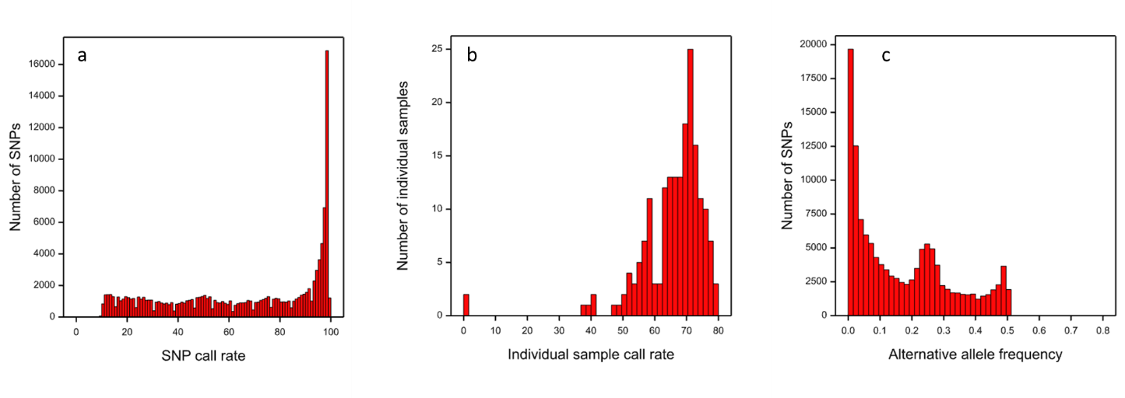

**Figure 2:** **Genetic map of mānuka obtained using genotyping by sequencing in the** EC201xEC103 **segregating population.**

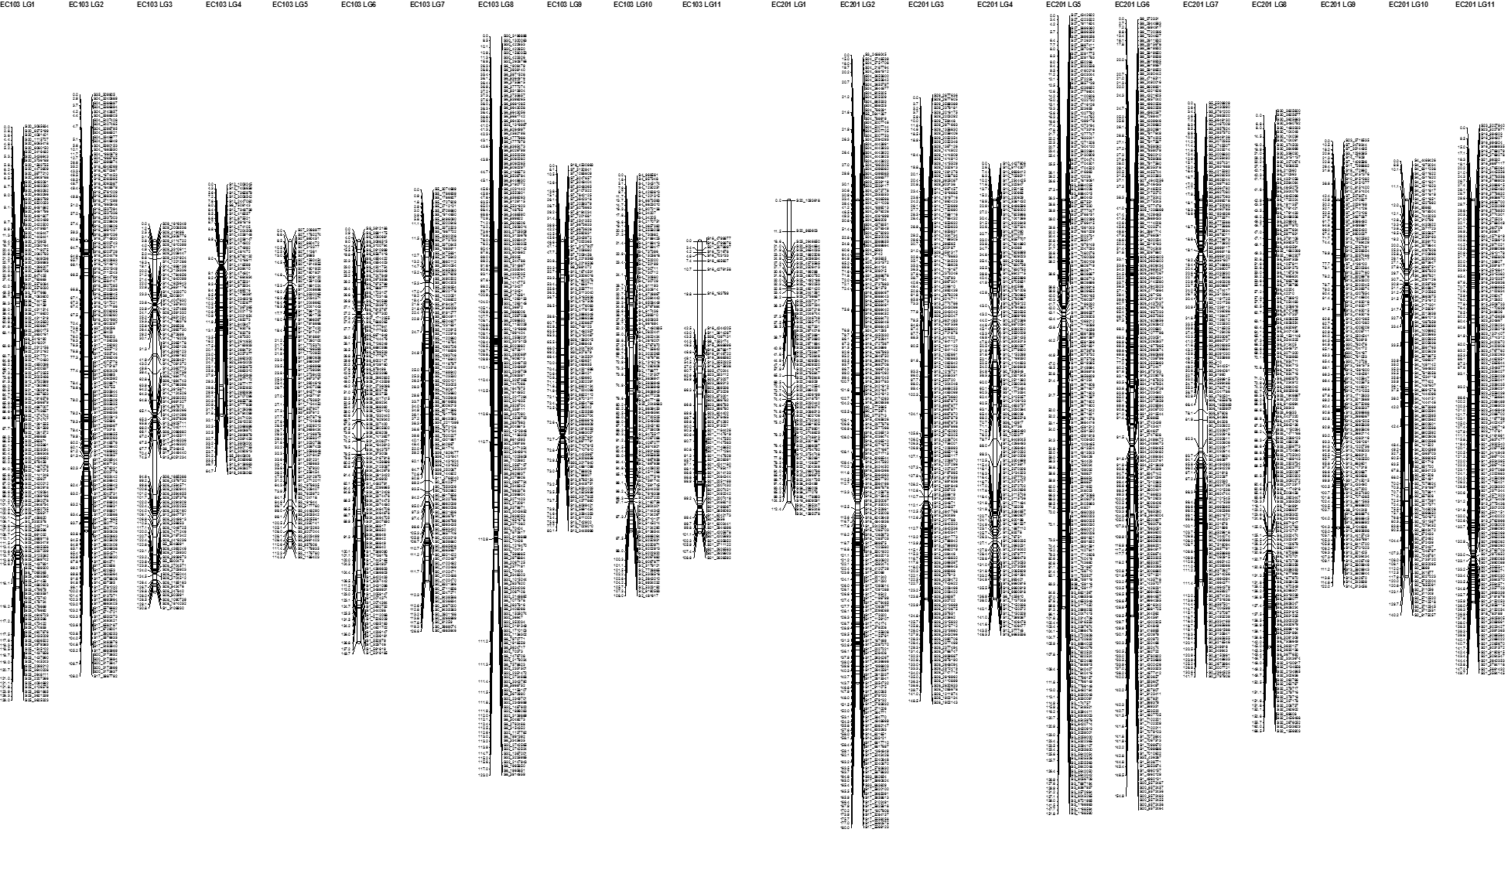

**Figure 3: Phenotyping for tree height in the** EC201xEC103 **mānuka population.**

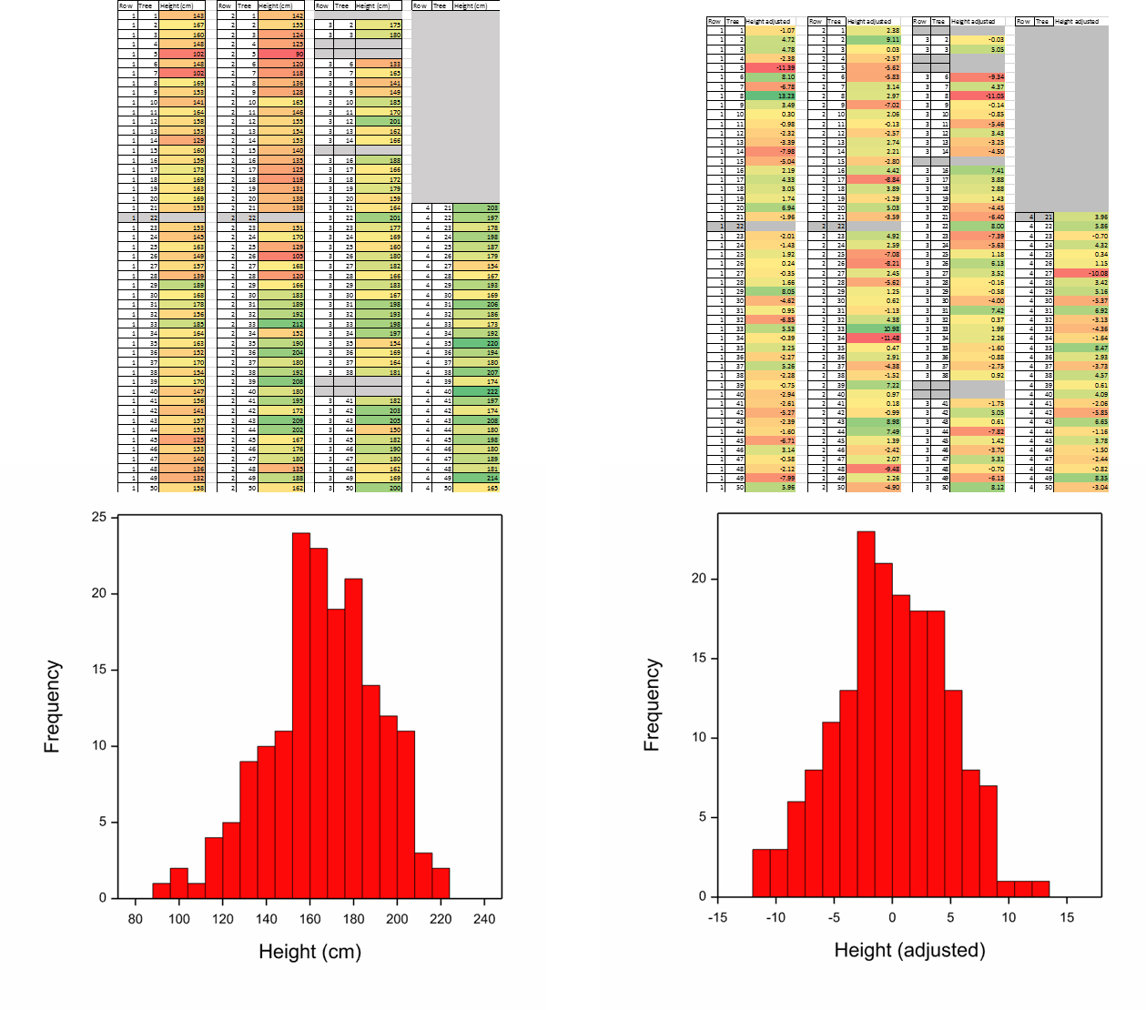

**Table 1: QTL detection for tree height in the manuka** EC201xEC103 **segregating population.**

|  |  |  |  |  |  |
| --- | --- | --- | --- | --- | --- |
| **Parent** | **Linkage group** | **LOD score** | **% var (REML)** | **Significance** | **Closest marker** |
| EC103 | 2 | 5.85 | 6.1 | 99% GW | S18_2229606 |
| EC103 | 9 | 5.91 | 11.2 | 99% GW | S7_6592831 |
| EC103 | 10 | 3.76 | 1.2 | 95% GW | S2_3232565 |
| EC103 | 6 | 2.88 | 2.6 | 90% GW | S26_2662832 |
| EC103 | 7 | 3.12 | 6.5 | 90% GW | S0_8042577 |
| EC201 | 3 | 12.58 | 21.2 | 99% GW | S15_1226993 |
| EC201 | 2 | 6.68 | 10.5 | 99% GW | S17_1091289 |
| EC201 | 6 | 3.47 | 3.9 | 95% GW | S9_4321626 |
| EC201 | 7 | 3.71 | 3.3 | 95% GW | S0_2782715 |
| EC201 | 9 | 3.15 | 6.0 | 90% GW | S13_5208678 |